**KIIT Deemed to be University**

School of Computer Engineering

Bhubaneswar, ODISHA 751024



**CERTIFICATE**

This is certify that the project entitled

**“FACE RECOGNITION“**

submitted by

**GROUP MEMBER A - PRATYUSH KUMAR SAHOO (21052685)**

**is a record of bonafide work carried out by Me, in the partial fulfillment of the requirements for the award of Degree of Bachelor of Engineering (Computer Science & Engineering )at KIIT Deemed to be university, Bhubaneswar. This work is done during the year 2023-2024, under our guidance.**

**Date:30 / 03 / 2024**

**GUIDE NAME:-**

**ABINASH PANDA**

**Acknowledgements:**

We are profoundly grateful to **ABINAS PANSA** of Affiliation for his expert

guidance and continuous encouragement throughout to see that this project rights its

target since its commencement to its completion. .....................

**NAME-PRATYUSH KUMAR SAHOO**

**(21052685)**

**ABSTRACT:**

Face Recognition is a computer application that is capable of detecting, tracking, identifying or verifying human faces from an image or video captured using a digital camera. Although a lot of progress has been made in the domain of face detection and recognition for security, identification and attendance purposes, there are still issues hindering the progress to reach or surpass human level accuracy. These issues are variations in human facial appearance such as; varying lighting condition, noise in face images, scale, pose etc. This research paper presents a new method using Local Binary Pattern (LBP) algorithm combined with advanced image processing techniques such as Contrast Adjustment, Bilateral Filter, Histogram Equalization and Image Blending to address some of the issues hampering face recognition accuracy so as to improve the LBP codes, thus improve the accuracy of the overall face recognition system. Our experiment results show that our method is very accurate, reliable and robust for a face recognition system that can be practically implemented in a real-life environment as an automatic attendance management system.

**Keywords:**

Face recognition,Image blending, facial feature detection/tracking, information theory, visual learning techniques.

**Contents:**

**1)**Introduction

**2)**Motivation

**3)**Innovation of Project

**4)**Scope of the Project

**5)**Face Detection

**6)**Conclusion

**7)**References

**LIST OF FIGURE**



**Introduction:**

In the general framework of face recognition, a probe still-image is matched against a collection of images -- the database of the people known by the system. As a result, most of the work carried out in face recognition by computer is limited to the comparison between face images. The best reported results of the mug-shot face recognition problem are obtained with jet-based elastic matching and principal component analysis. In these approaches, the overall face detection, facial feature localization, and face comparison is carried out in a single step. Provided that video cameras, frame grabbers, and the corresponding software support are becoming more readily available, face recognition with video sequences poses a new, interesting problem. Straightforward extension of the known face recognition approaches are not suitable, since the computational resources required for storing a video sequence for each individual in the database, and matching an input video segment with a video database are most likely prohibited. A new representation for the face knowledge is required for the database, as well as better face-learning techniques than just keeping pictures of the people known by the system. In this paper, we present our research progress towards face recognition with video sequences. First, we briefly describe a visual-learning technique that leads to an automatic, real-time, robust face and facial feature detection and tracking system. Such a system provides the starting point and the setup for automatic processing of video sequences with faces. We also introduce in this paper a fast algorithm for 2D-template matching, which provides an efficient way for massive image comparison; and finally, we describe a template-matching based, real-time face recognition system.

**MOTIVATION:**

We developed this Face Detection Project for our Indian Army, Security CCTV Police and even Common Use of people to detect Face in single and group of peoples in Images.Today In world Security is advancing to detect terrorists and criminals easily in crowds. This Project will easily detect faces, even old\blur Images with very less time of execution.This Face Detection Code can be deployed and used in any application camera, security apps and website to find faces easily.

**Innovation of Project:**

1)It can Detect faces easily with less time of execution.

2)It can Detect faces in any quality of Images, even blur.

3)It can Detect single, double or even multiple faces in any Image.

4)It can tell the number of people/faces in Image.

5)It is fully automatic face recognition system

6)It is one of the best in today's world as per the number of codes used in the system.

7)It use Haar feature based Algorithm to detect which it makes very accurate and fast processing of face detection

**METHOD:** Building such a system from scratch using the Scala programming language helped achieve a better understanding of the field as well as its advantages and disadvantages compared to other biometric authentication methods. After some research, the decision to do face detection using an OpenCV library for Scala and face recognition using Microsoft’s Face API was unavoidable due to not having a system that could reliably do both detection and recognition in the project’s circumstances.

**Scope of the Project:**

The future of facial recognition technology is bright. Forecasters opine that this technology is expected to grow at a formidable rate and will generate huge revenues in the coming years. Security and surveillances are the major segments which will be deeply influenced. Other areas that are now welcoming it with open arms are private industries, public buildings, and schools. It is estimated that it will also be adopted by retailers and banking systems in coming years to keep fraud in debit/credit card purchases and payment especially the ones that are online. This technology would fill in the loopholes of the largely prevalent inadequate password system. In the long run, robots using facial recognition technology may also come to foray. They can be helpful in completing the tasks that are impractical or difficult for human beings to complete.

**Face Detection:**

Face recognition detection is a problem of significant importance and difficulty. Automatic detection of targets is the first step in most automatic vision systems. Most of the research carried out by the computer vision community relies on the robust detection and accurate location of objects within the tested images. In many cases, algorithms for automatic, visual detection of targets are not provided. In other cases, rather useless algorithms are used which are based on assumptions (for example, controlled environment) that are not suitable for real-life applications. Although it seems an easy task for the human- vision system, machine detection of visual patterns is difficult due to the wide range of variations present in real-live data. Aside from the intra-class variation proper of any family of objects, visual detection of patterns has to deal with other sources of image variations such as light conditions, object pose, imaging system, etc. Considering it as a pattern, the face is a challenging object to detect and recognize. The face anatomy is rigid enough so that all faces are similar in structure, yet we are very much different from each other. In addition to individual variations and the racial variations, there are the facial expressions, which allow an individual to change his or her appearance significantly.

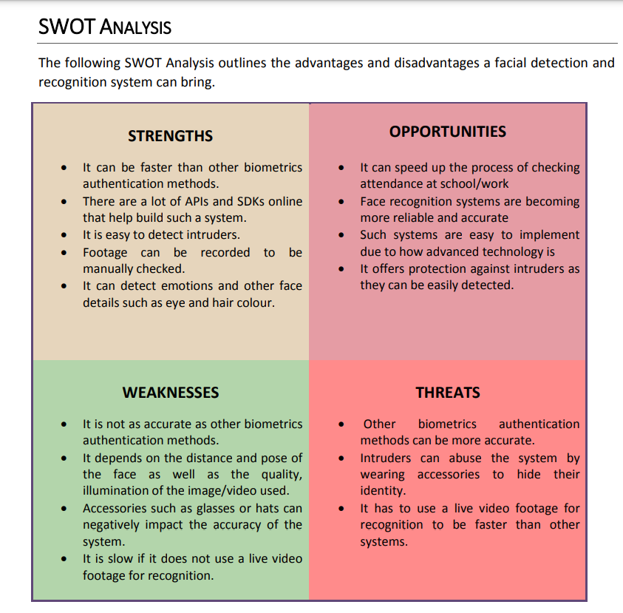

**Conclusion:**

In conclusion, in our research, after preprocessing the input face images using some advanced image processing techniques such Contrast Adjustment, Bilateral Filter, Histogram Equalization, so as to have better image features and the same advanced image processing techniques will be applied to the training/template face images plus an image blending method to ensure high quality training/template face images.

**References:**

<https://link.springer.com/chapter/10.1007/978-3-642-72201-1_9>

<https://www.sciencedirect.com/science/article/pii/S2590005619300141#sec6>

https://intranet.birmingham.ac.uk/it/innovation/documents/public/Experiments/Face-Detection-Recognition-Report.pdf

THANK YOU………….